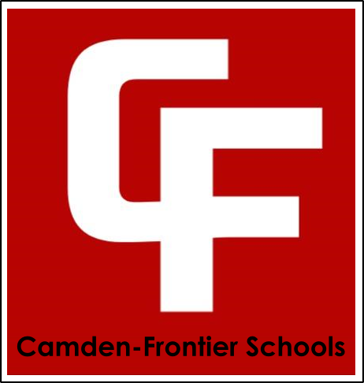
Camden-Frontier Board of Education
Athletics Committee Meeting – 6:30 PM - October 2, 2023 - HS Office

- Call to Order & Roll Call
Our Mission
The Camden-Frontier School community including staff, students, parents and stakeholders will provide a foundation of educational opportunities that enable all students to succeed in our changing society.
  - Members Present- Jesse Crow, Gary Morrison, Nykol Byrd
- Discussion Items
  - Mascot Update
  - General Update

Mascot update was presented with the list of potential nicknames:
Potential Nicknames
Falcons
RedHawks
RedBulls
RedWolves
Patriots
Crusaders
Lakers
Stingers
Cobras
Thunder/Bison
Cadets
Eagles
Screaming Eagles
Harvesters
Lumberjacks
Process will proceed with staff, board and community input being solicited over the next two weeks
The general update included information regarding the Navigate 360 program and the roll out.

