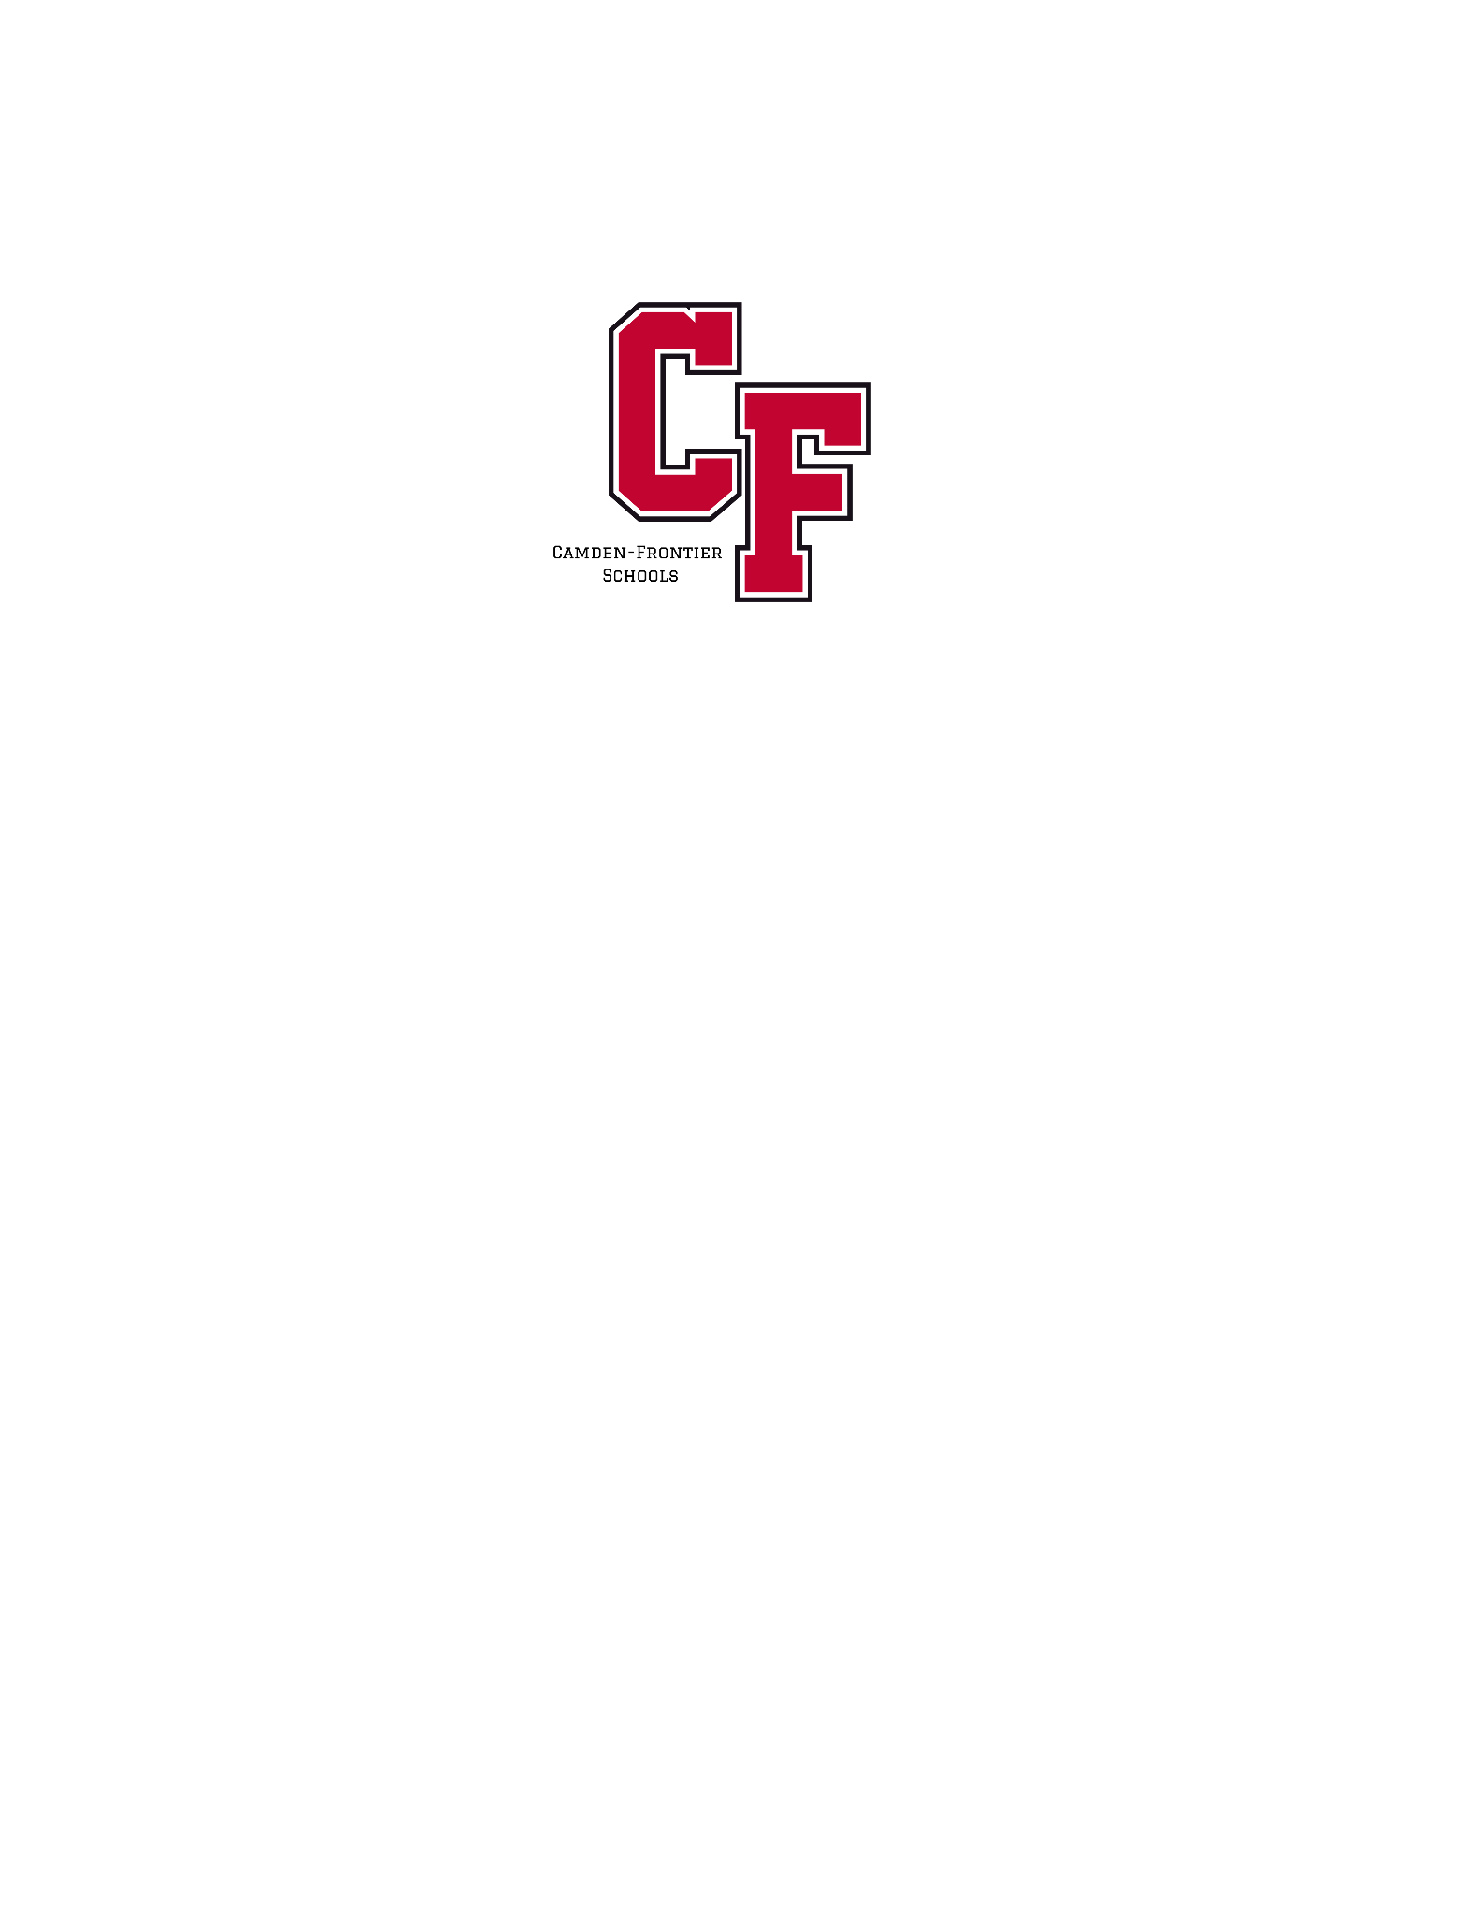
Camden-Frontier Board of Education
Regular Board Meeting - 6:00 PM - August 18, 2025 - Band Room

- Call to Order & Roll Call
Our Mission
The Camden-Frontier School community including staff, students, parents and stakeholders will provide a foundation of educational opportunities that enable all students to succeed in our changing society.
- Pledge of Allegiance
- Changes or Additions to the Agenda
- Approval of Previous Meeting Minutes
  - July 21th Regular Meeting Minutes
  - August 11th Work Session Minutes
- Public Comment
- Board Correspondence
- Presentations:
- Reports
Our Vision
All Camden-Frontier students will be responsible for achieving academic, social and workplace competencies and for becoming life-long learners.
  - Superintendent’s Report
  - President’s Report
  - Treasurer’s Report
  - ISD Report
  - Student Council Report
- Action Items
  - July Payables
  - Milk Bid Approval
  - CF BOE MASB Delegate appointment
  - CFEA Contract Approval
  - CFESA Contract Approval
  - Hiring Recommendations
    - Josh Leach MS Girls’ BB

- Public Comment
- Adjournment

